

PAY PARKING USER`S GUIDE

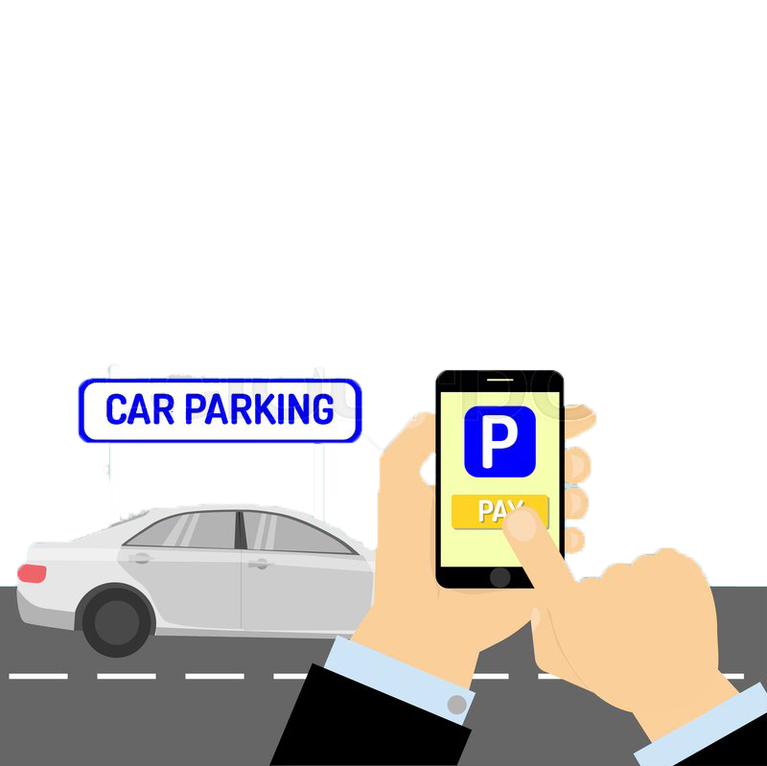



Type your username & password then click LOG IN

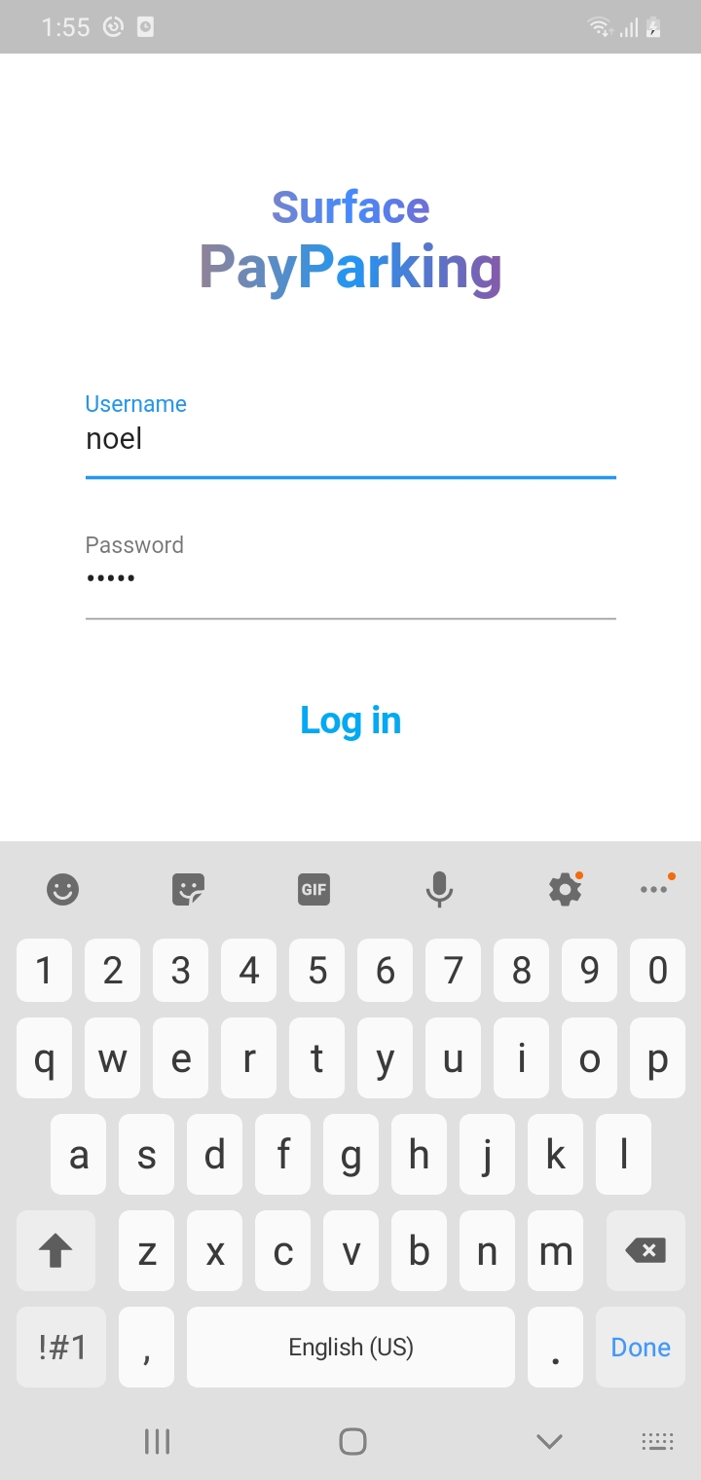



1. INPUT THE PLATE #
2. SELECT THE VEHICLE TYPE
3. SELECT THE LOCATION
4. THEN SLIDE TO CONFIRM

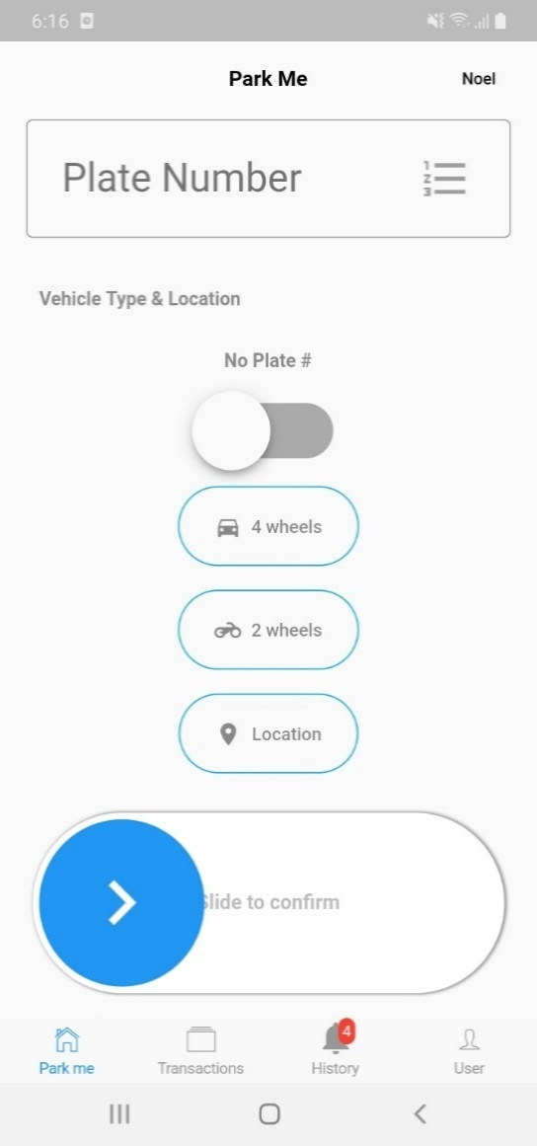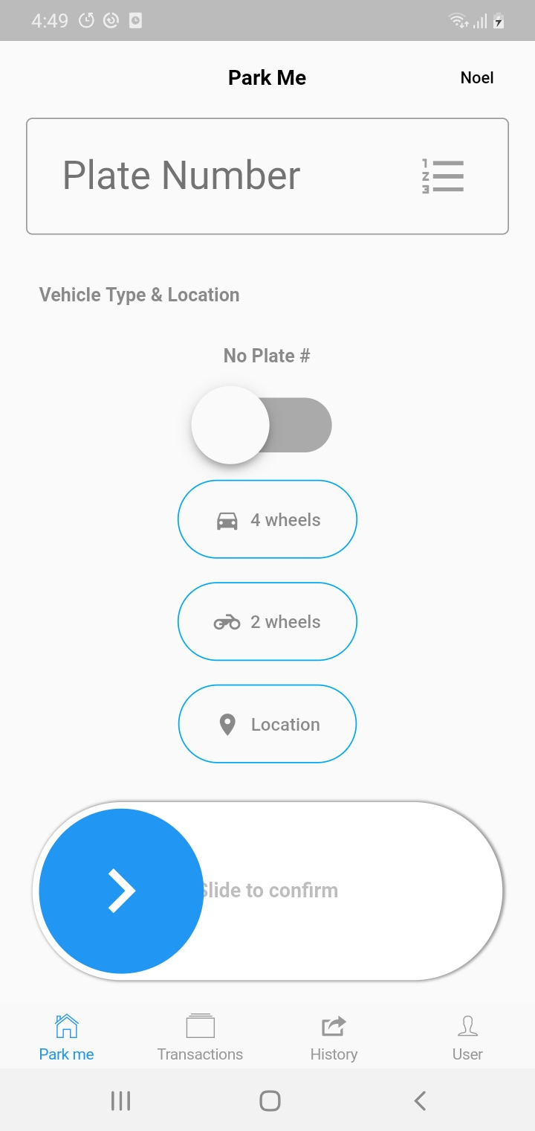



CLICK PROCEED TO PRINT THE COUPON AND TICKET

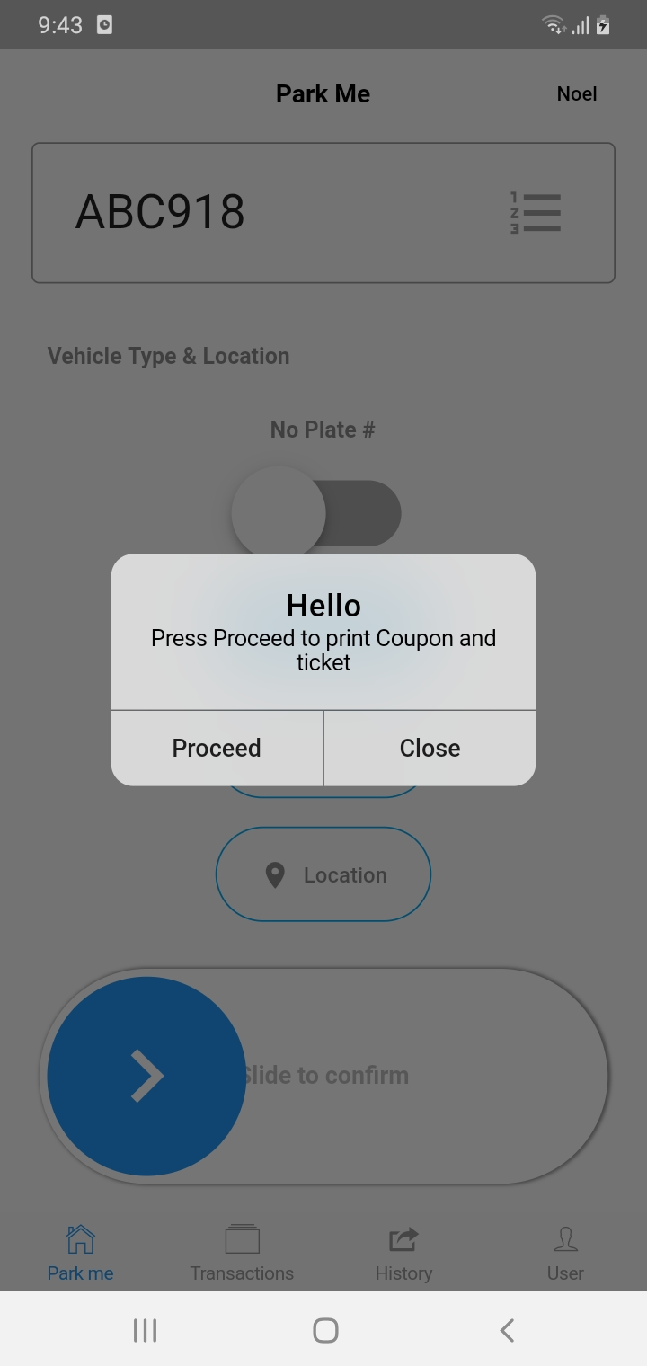



PRESS(LONG PRESS) TO PRINT OR GENERATE THE COUPON AND PAY PARKING TICKET

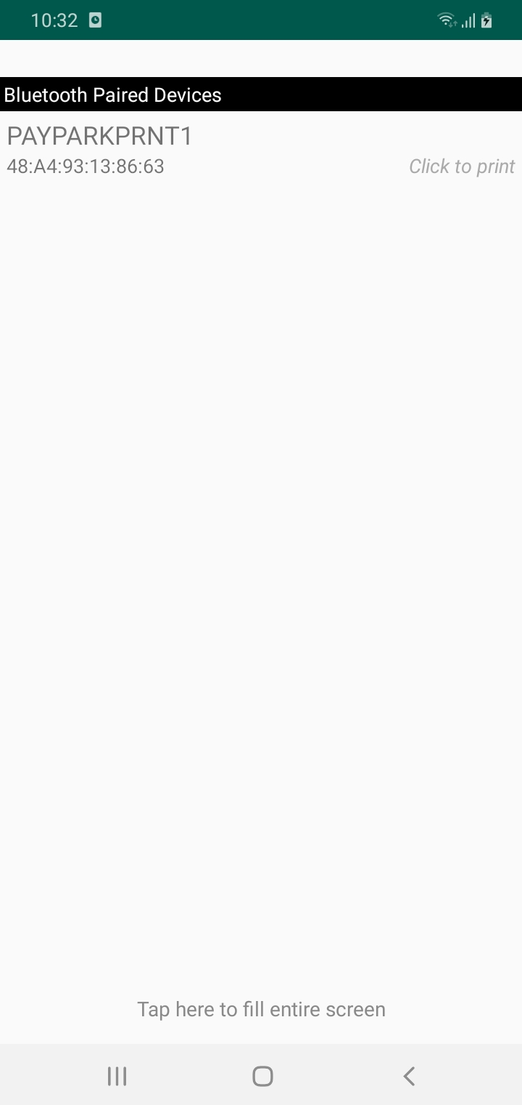



DISPLAY PROCESSING

1. GENERATE SURFACE PAY PARKING COUPON
2. GENERATE SURFACE PAY PARKING TICKET

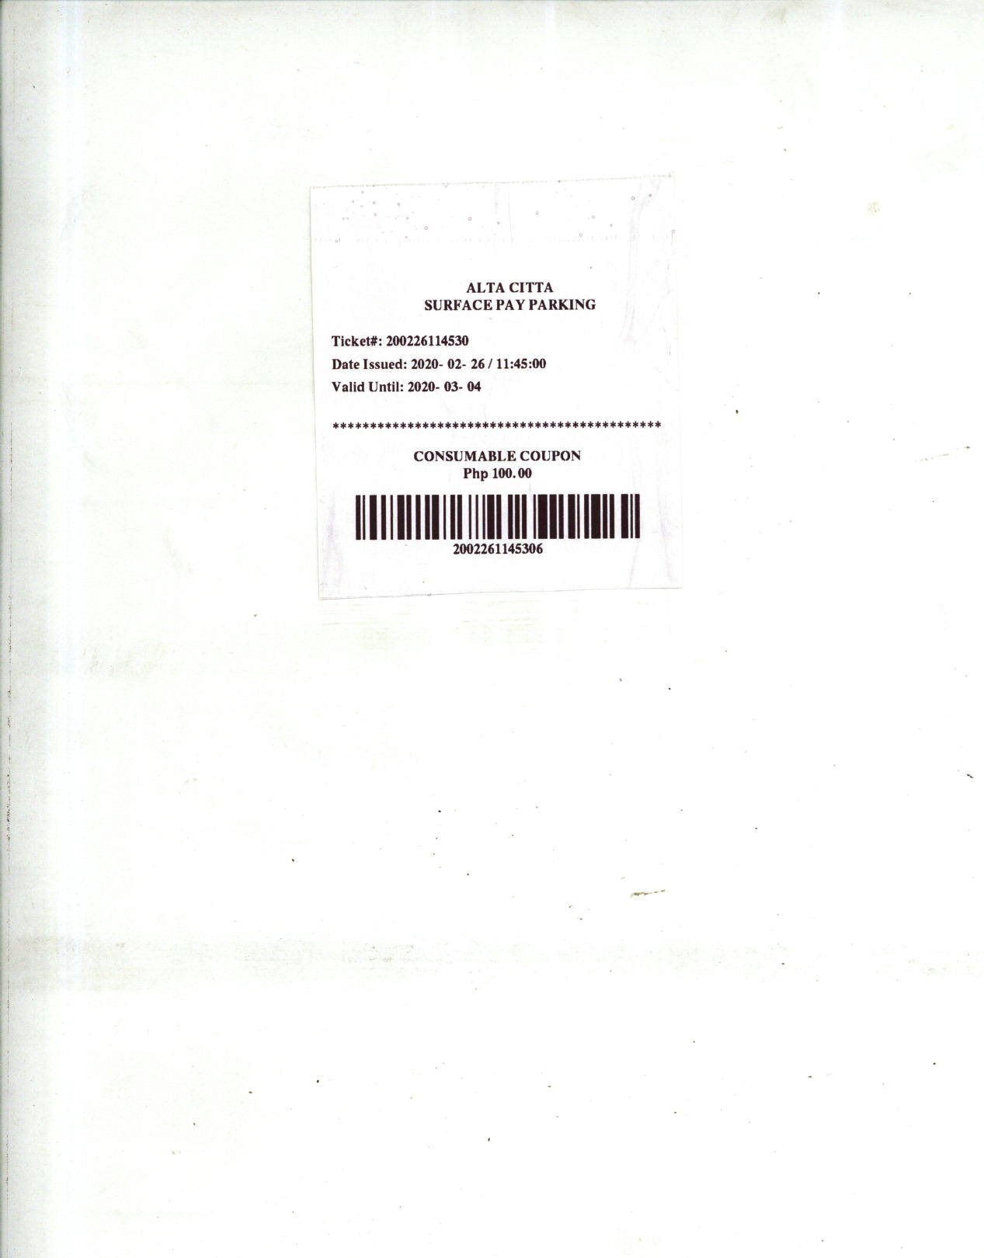



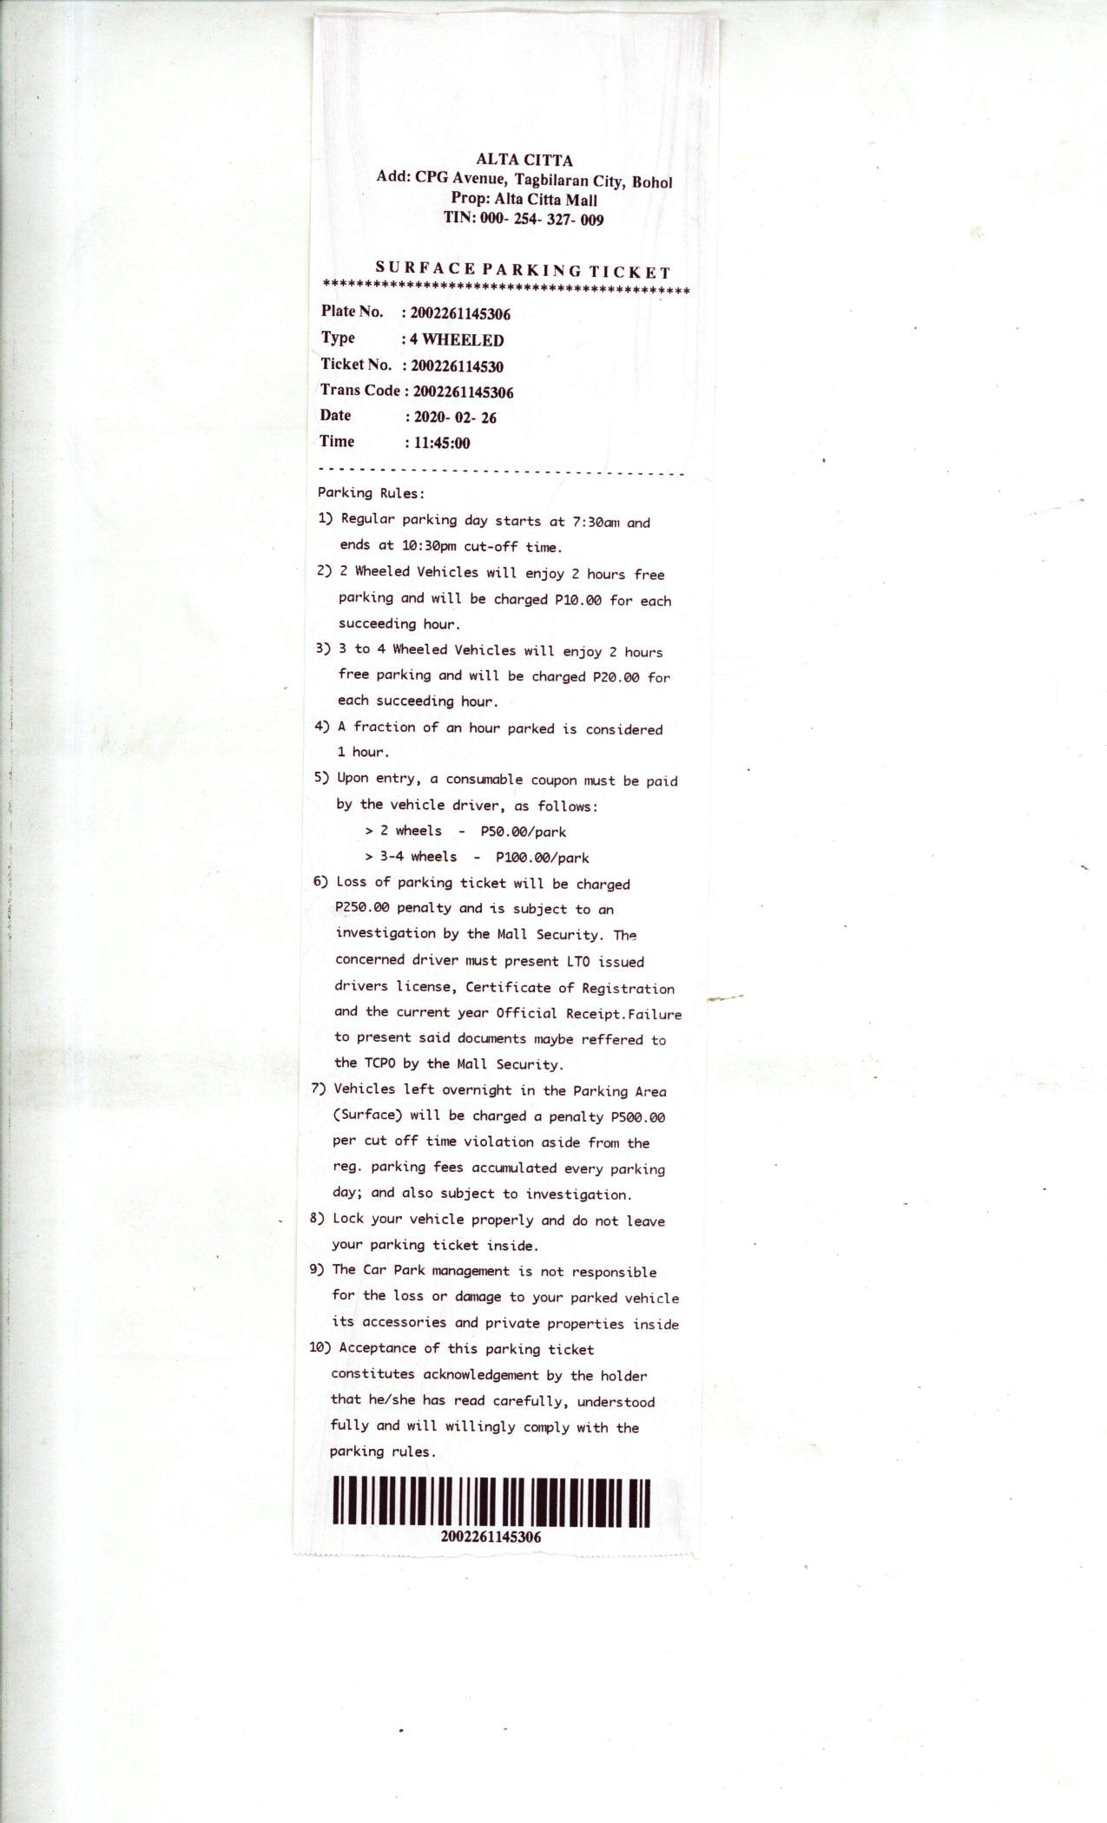



**TRANSACTIONS MENU**

LEGEND

1. Above 2 Hours
2. Almost 2 Hours

NAME OF INCHARGED

1. 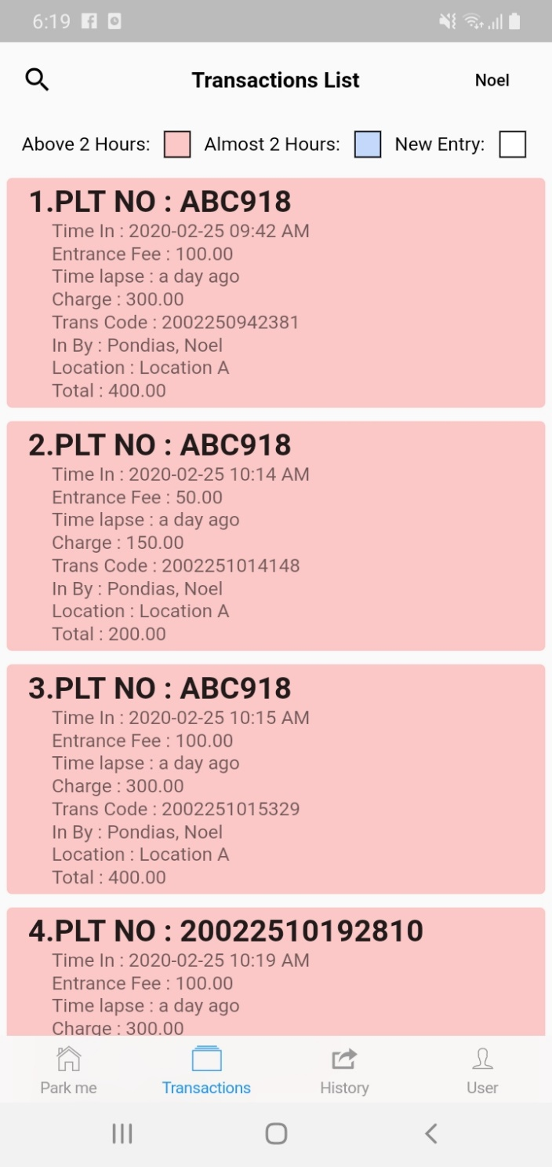 New Entry

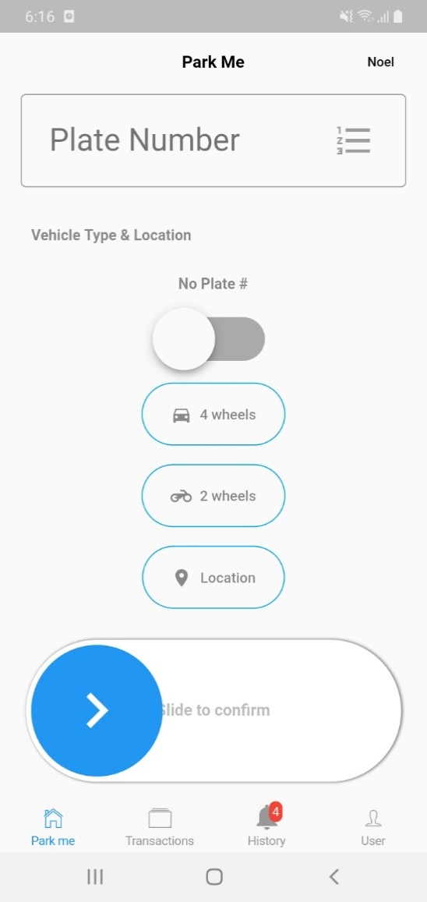



1. **Above 2 hours Vehicles**

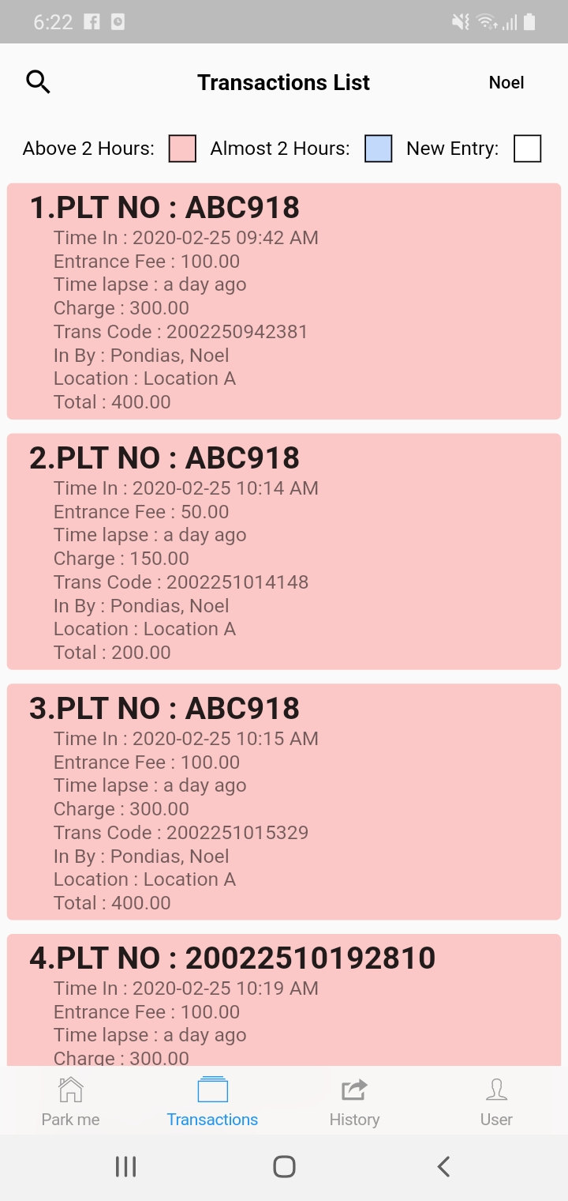

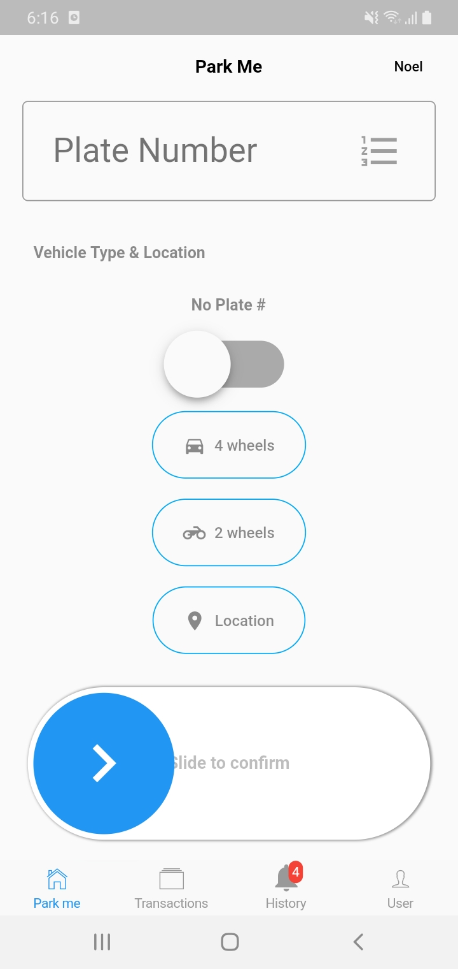



1. 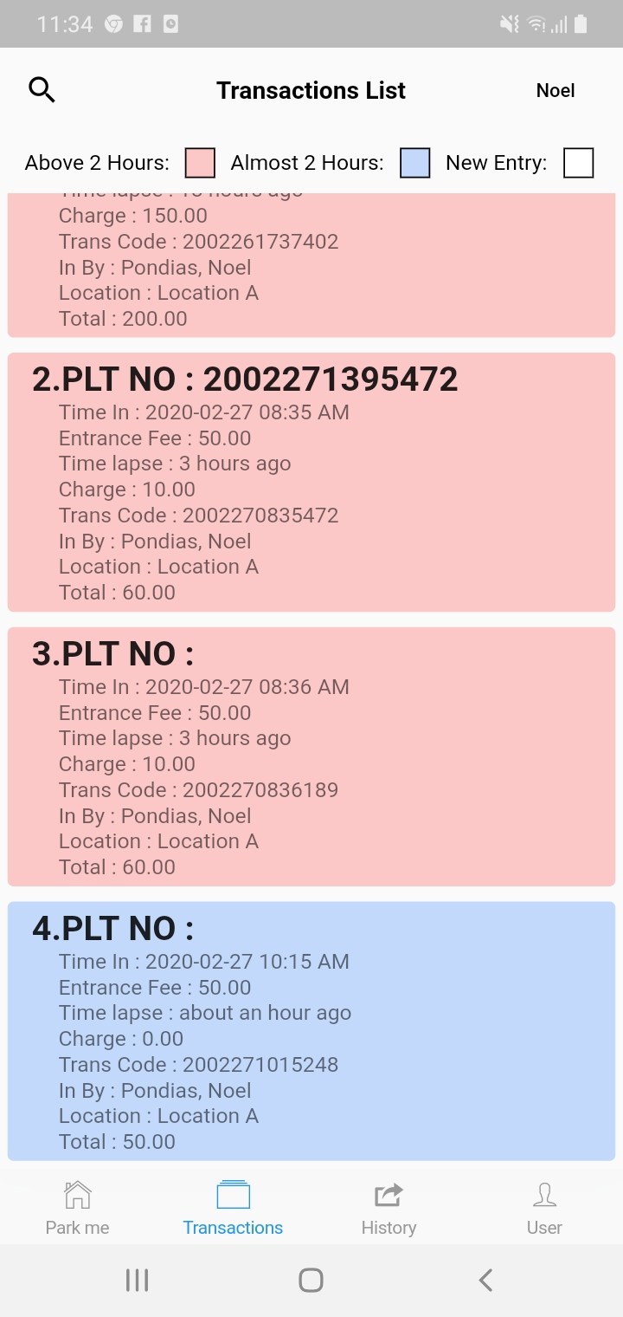**Almost 2 Hours Vehicles**





1. **New Entry Vehicles**

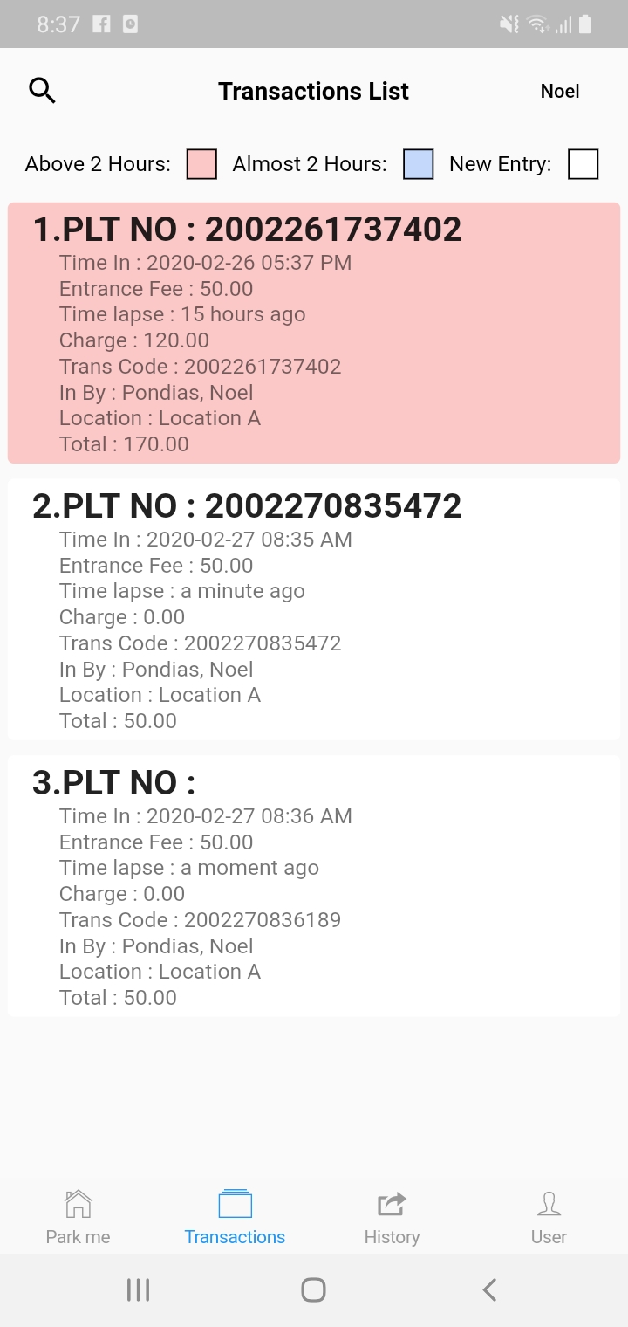





**GENERATE BILLING STATEMENT FOR ABOVE 2 HOURS**

GO TO TRANSACTIONS LIST

SELECT ABOVE 2 HOURS VEHICLES

1. PRESS(LONG PRESS) TO PRINT OR GENERATE SURFACE PAY PARKING BILLING STATEMENT

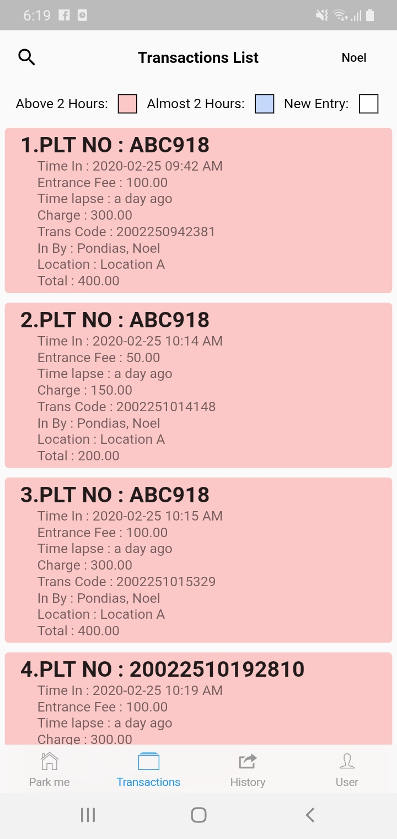







1. SELECT LOGOUT & PRINT RECEIPT FOR SURFACE PAY PARKING BILLING STATEMENT

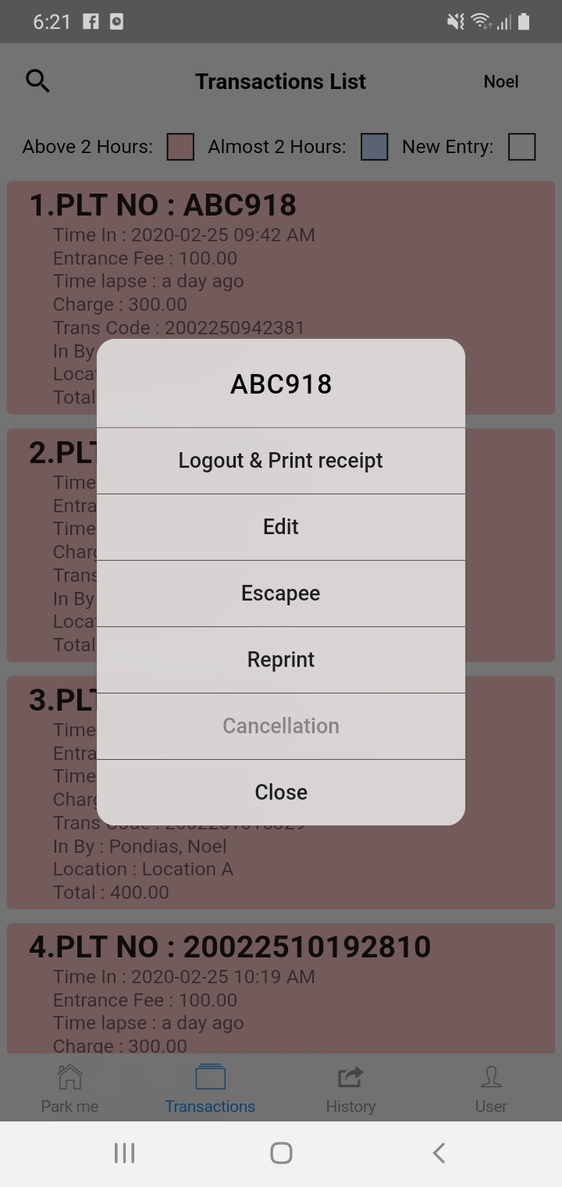



1. PRINT OR GENERATE SURFACE PAY PARKING BILLING STATEMENT

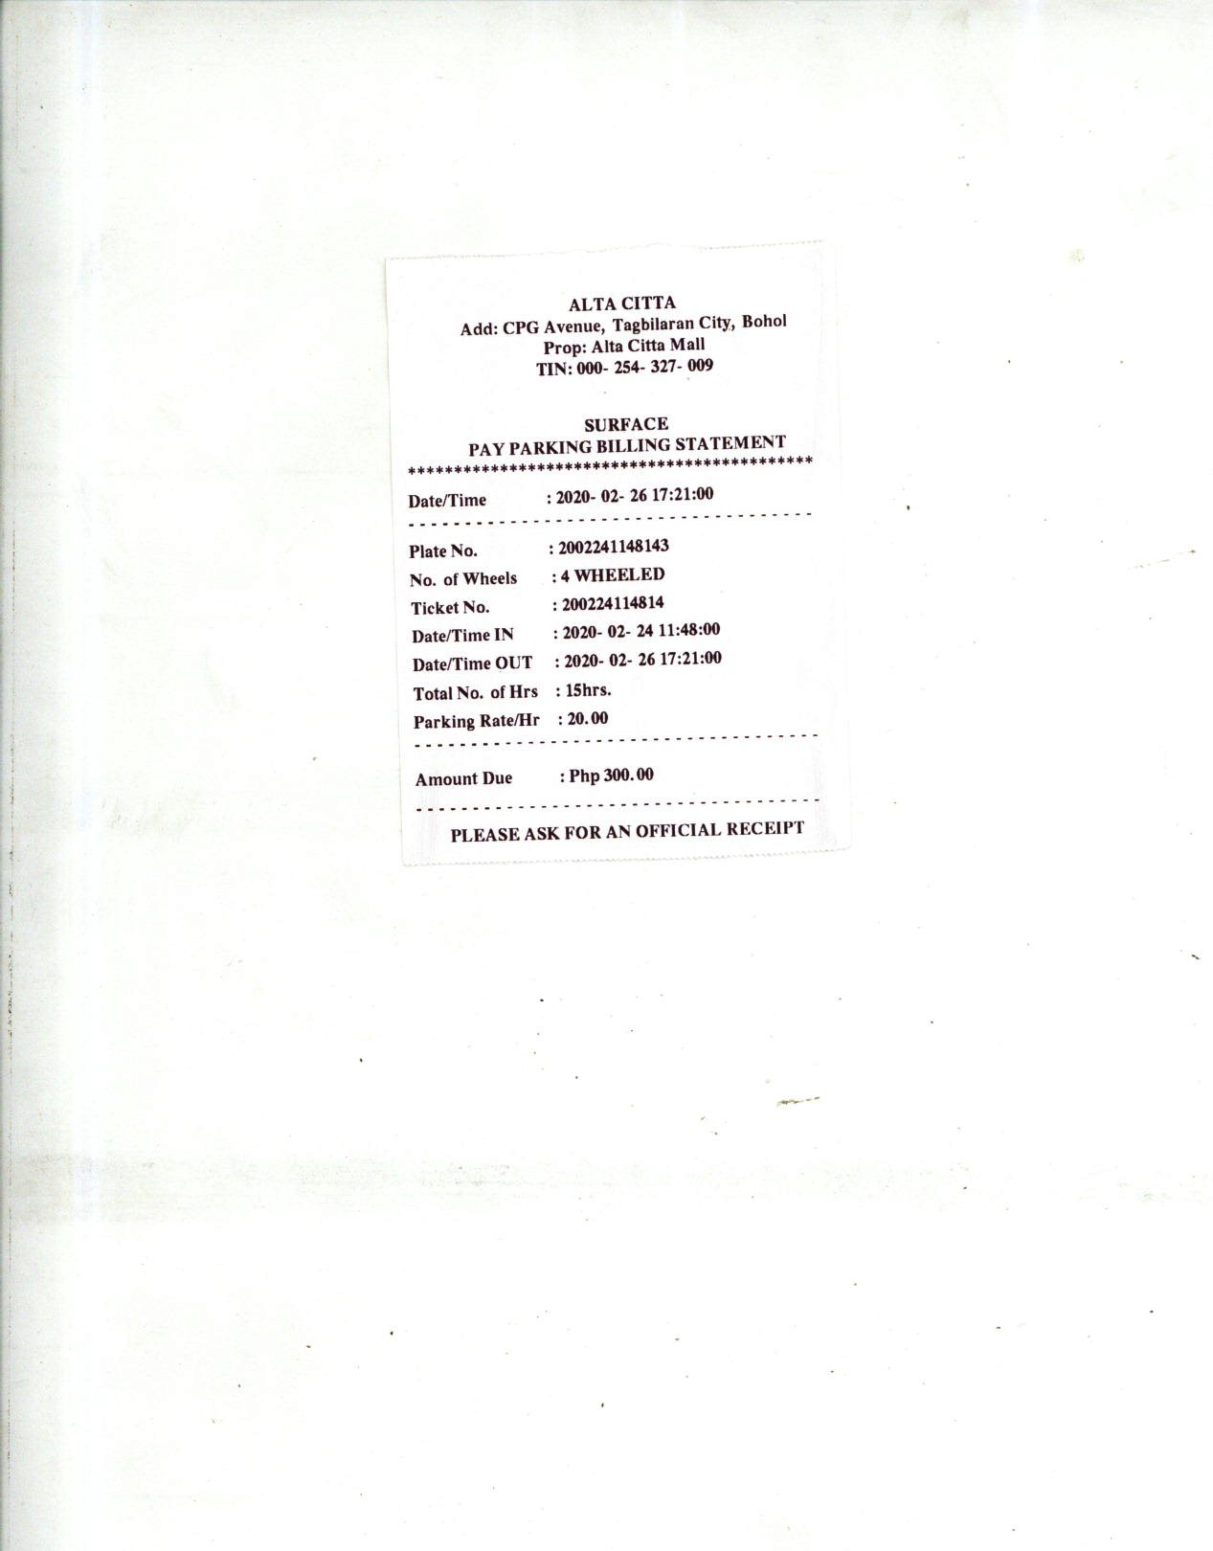



**HOW TO LOG OUT LESS THAN 2 HOURS**

GO TO TRANSACTIONS LIST

SELECT LESS THAN 2 HOURS VEHICLES

*NOTE: NO SURFACE PAY PARKING BILLING STATEMENT WILL BE GENERATED*

1. PRESS(LONG PRESS) TO LOGOUT

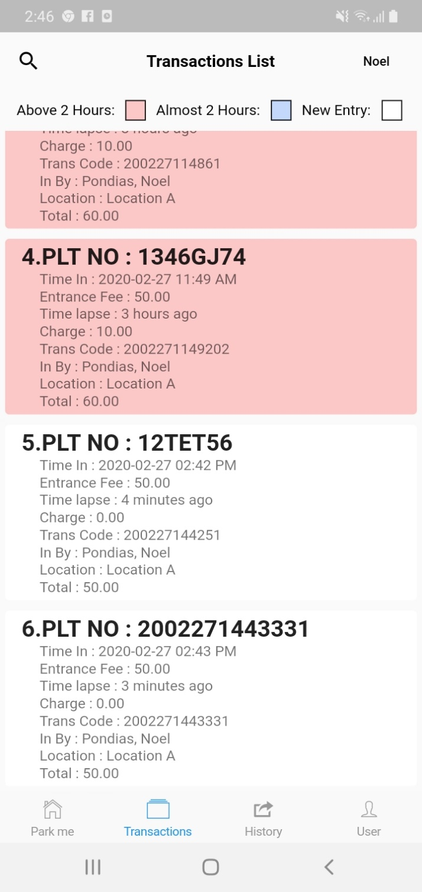







1. SELECT LOGOUT

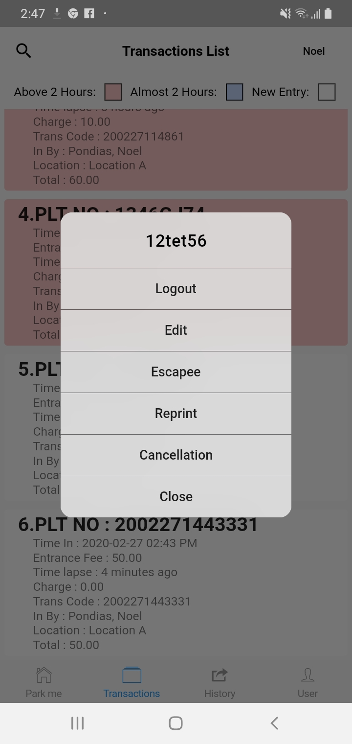



CLICK YES TO LOGOUT

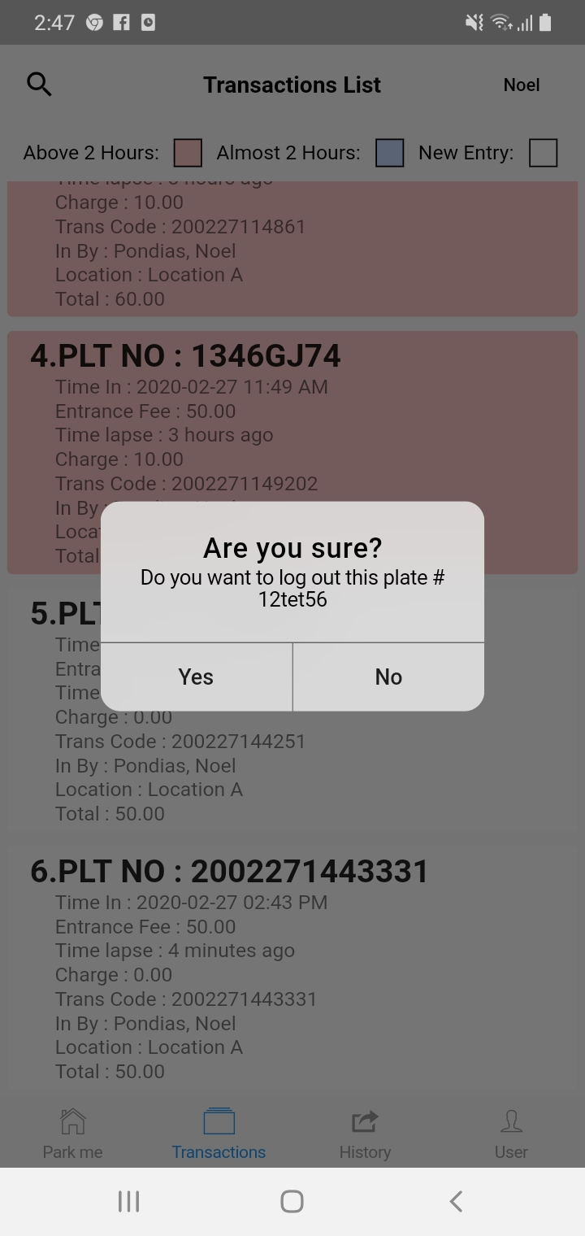



SUCCESSFULLY SAVE TO HISTORY

DISPLAY NOTIFICATION (DISPLAYS THE TOTAL NUMBER OF TRANSACTIONS ADDED TO HISTORY)

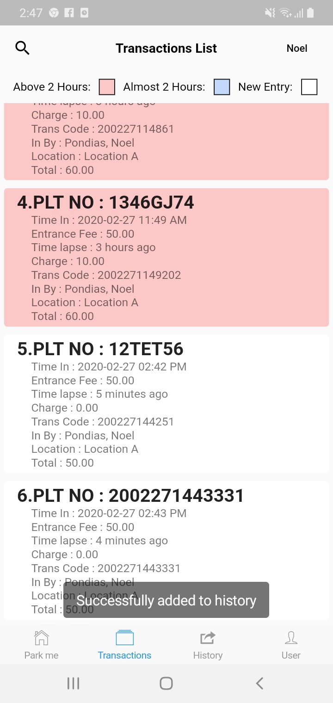





**HOW TO EDIT PLATE NUMBER**

GO TO TRANSACTIONS LIST

1. PRESS(LONG PRESS) TO EDIT PLATE NUMBER









1. SELECT EDIT

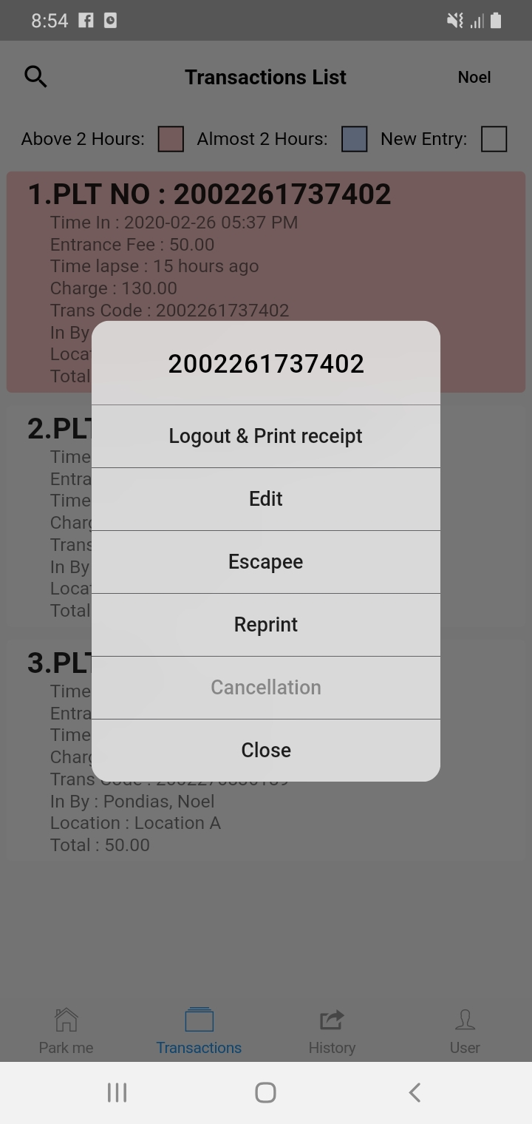



EDIT PLATE NUMBER

SLIDE TO CONFIRM

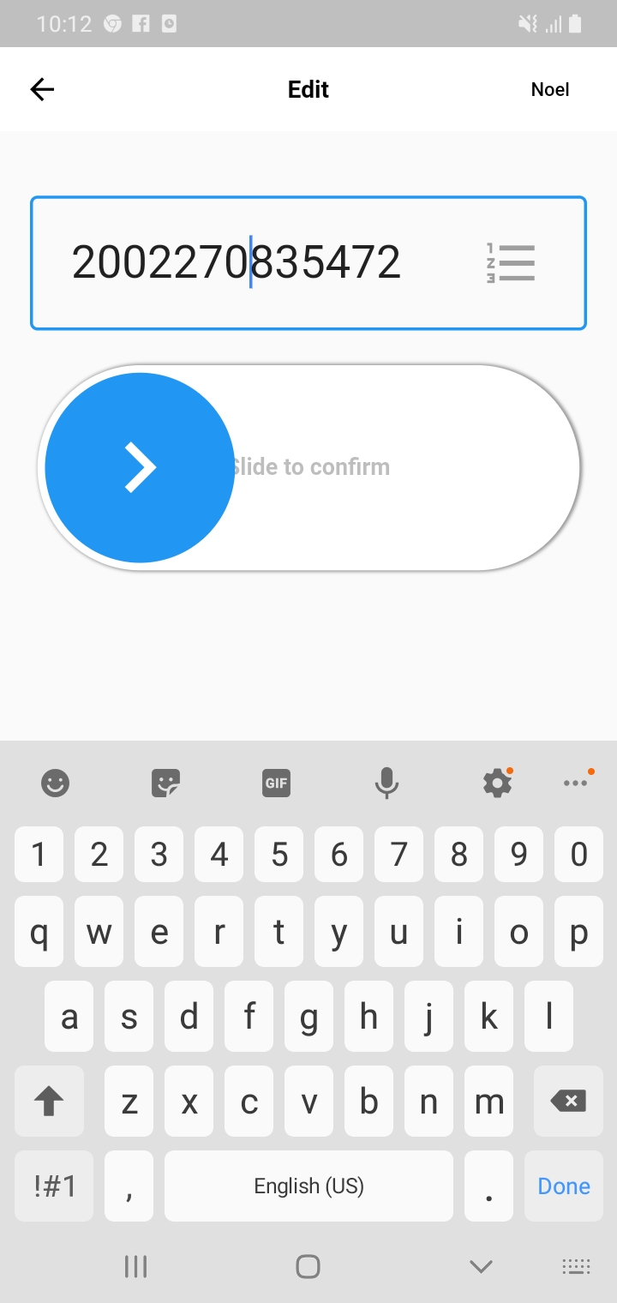





SUCCESSFULLY UPDATED

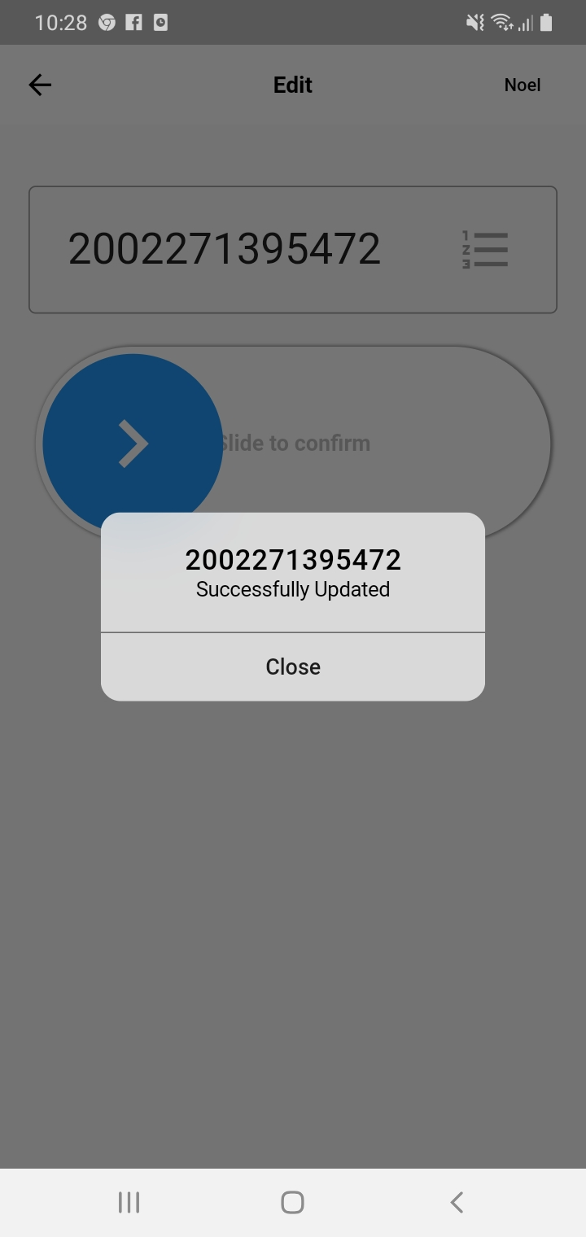



SLIDE DOWN TO REFRESH

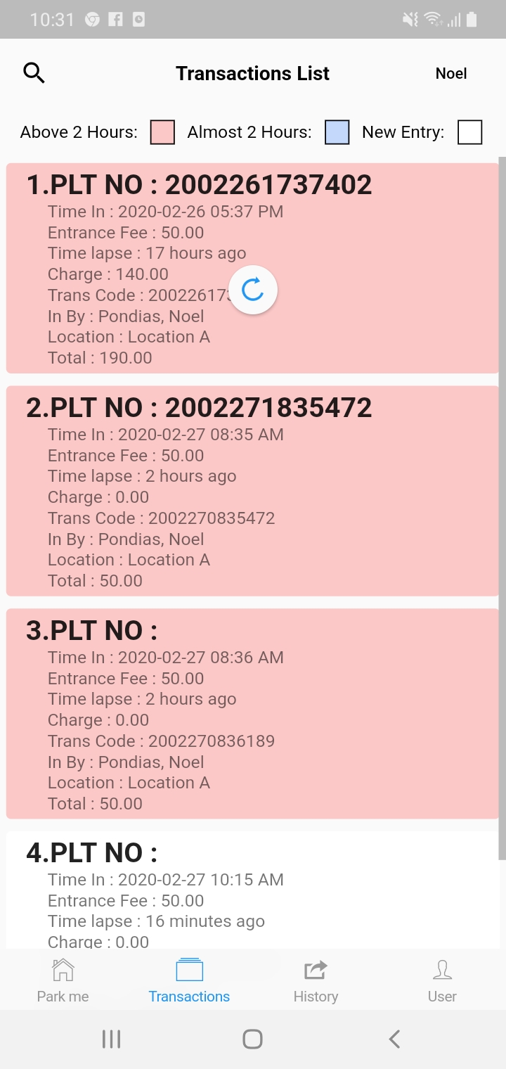







DISPLAY EDITED PLATE NUMBER

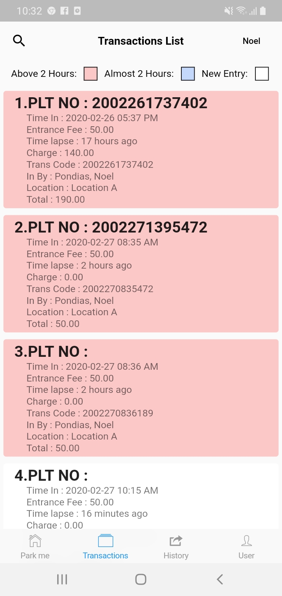





**HOW TO ADD BLACKLISTED PLATE NUMBER FOR ESCAPEE**

GO TO TRANSACTIONS LIST

SELECT ABOVE 2 HOURS VEHICLES

1. PRESS(LONG PRESS) TO INPUT ESCAPEE OR TO BLACKLIST PLATE NUMBER









1. SELECT ESCAPEE





INPUT MANAGER’S KEY

USERNAME & PASSWORD

CLICK PROCEED

*Note: Manager’s key is for Authorized Personnel or Area Security Guard only.*

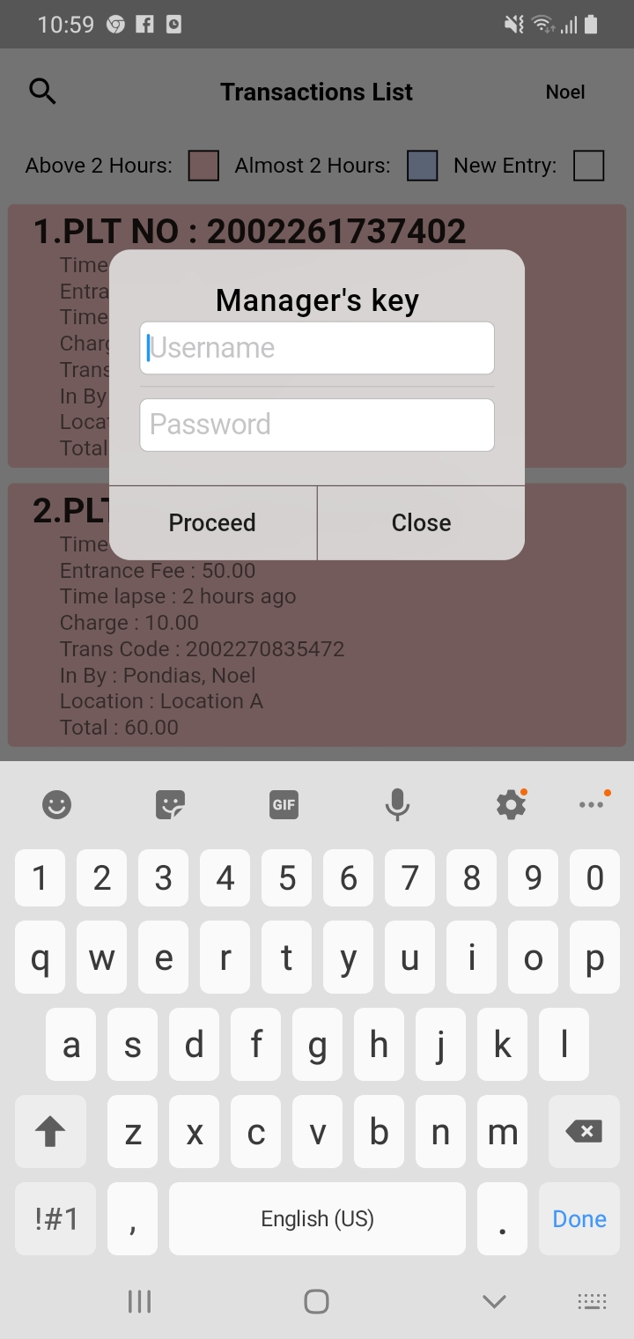



DISPLAY PLATE NUMBER

INPUT SECURITY NAME WITH SIGNATURE

INCHARGED SIGNATURE

CLICK (√) IF DONE

CLICK (X) IF YOU WANT TO CLEAR

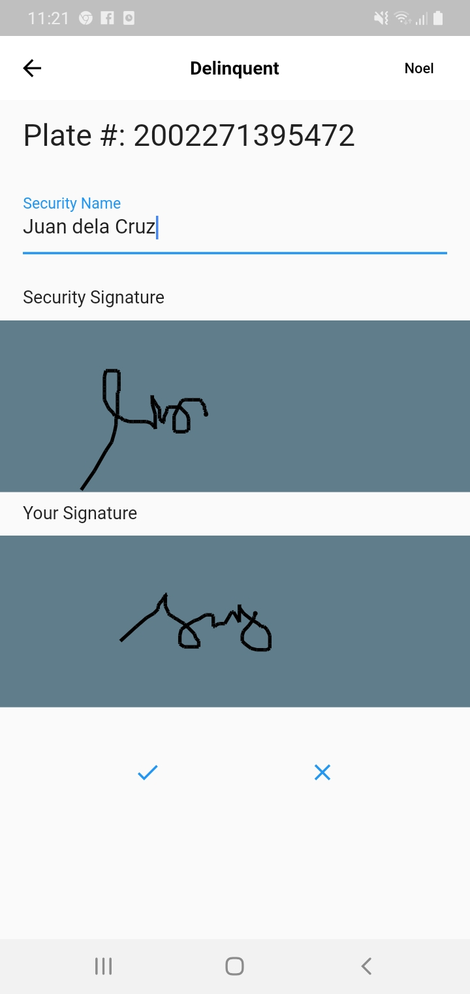



CLICK (√)

DISPLAY SUCCESS

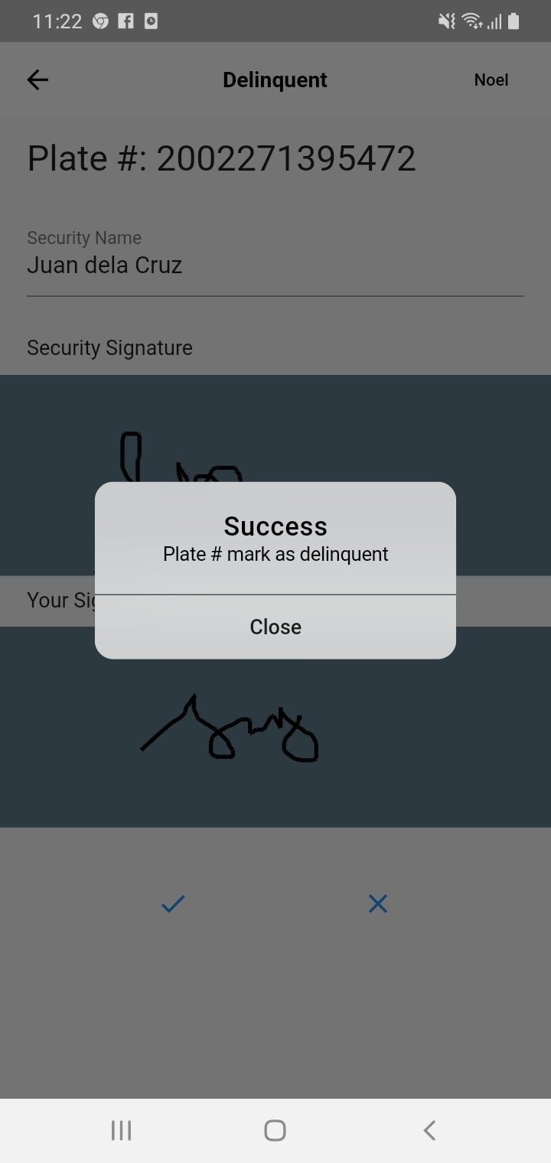



**HOW TO REPRINT SURFACE PAY PARKING COUPON AND TICKET**

GO TO TRANSACTIONS MENU

CLICK REPRINT

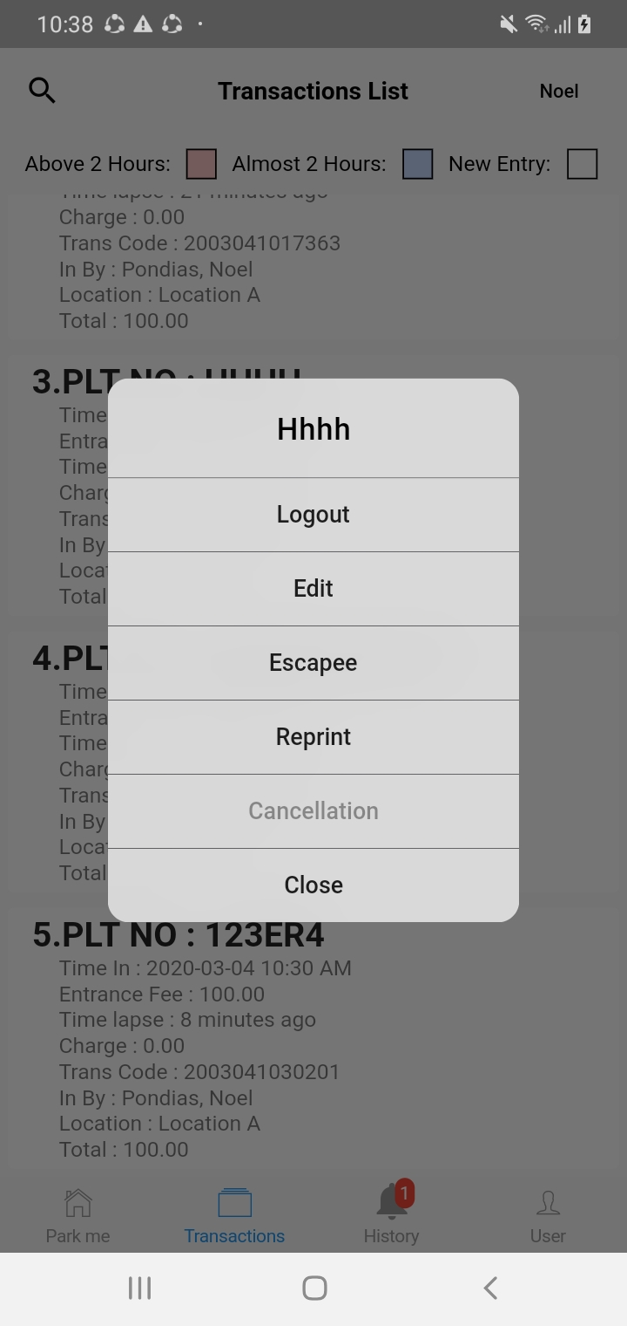



INPUT MANAGER’S KEY

USERNAME & PASSWORD

CLICK PROCEED

*Note: Manager’s key is for Authorized Personnel or Area Security Guard only.*

1. **GENERATE SURFACE PAY PARKING COUPON**
2. **GENERATE SURFACE PAY PARKING TICKET**

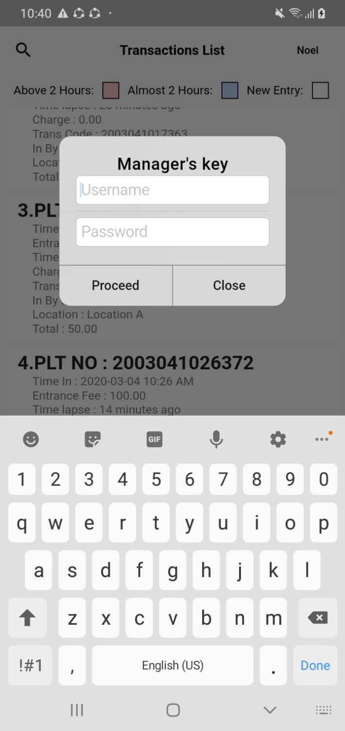







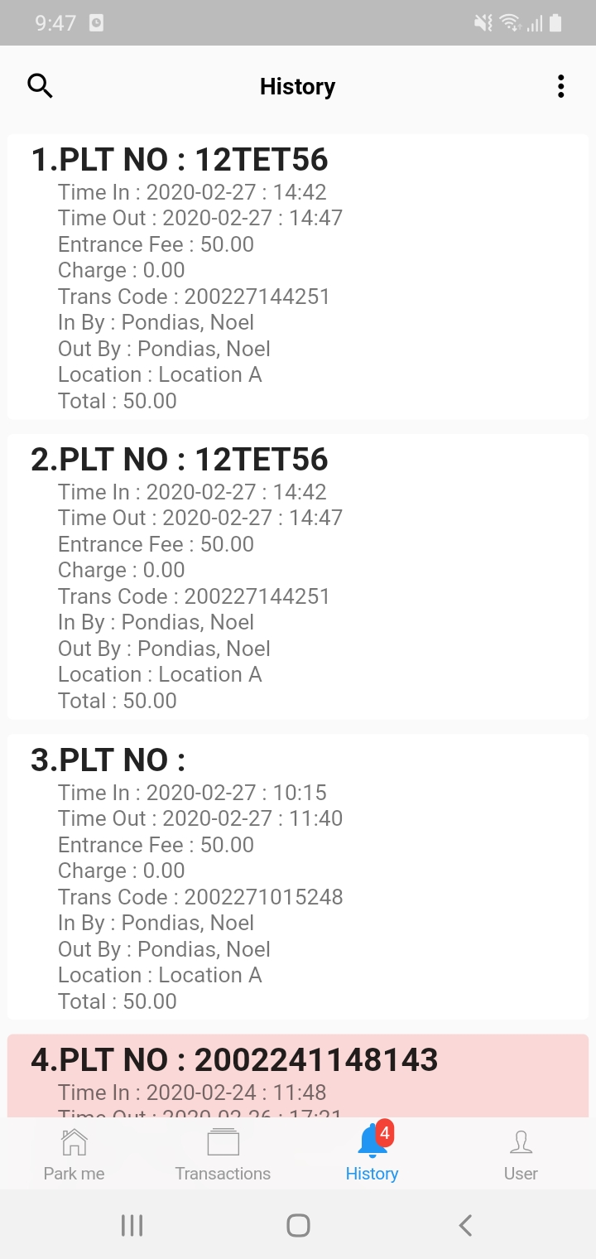**HISTORY MENU**

**CLICK HISTORY MENU**

**DISPLAY FOLLOWING:**

1. PLATE NUMBER
2. TIME IN
3. TIME OUT
4. ENTRANCE FEE
5. CHARGE/BILLING STATEMENT
6. DISPLAY TRANSACTIONS CODE
7. PERSON TRANS. IN
8. PERSON TRANS. OUT

**10**

1. LOCATION OF PERSON INCHARGED
2. TOTAL AMOUNT



**HOW TO REPRINT SURFACE PAY PARKING BILLING STATEMENT**

GO TO HISTORY

SELECT ABOVE 2 HOURS VEHICLES

1. PRESS(LONG PRESS) TO REPRINT SURFACE PAY PARKING BILLING STATEMENT

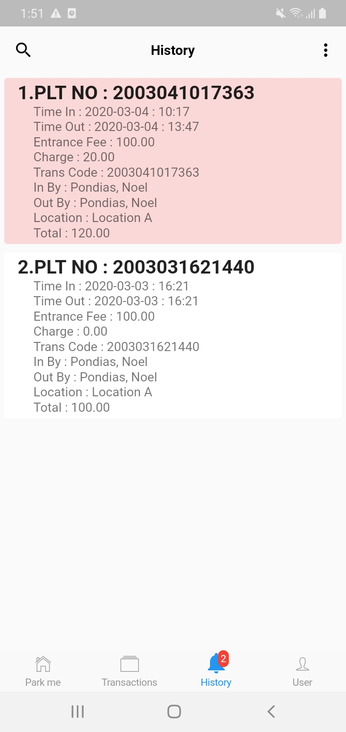





CLICK PROCEED

GENERATE SURFACE PAY PARKING BILLING STATEMENT

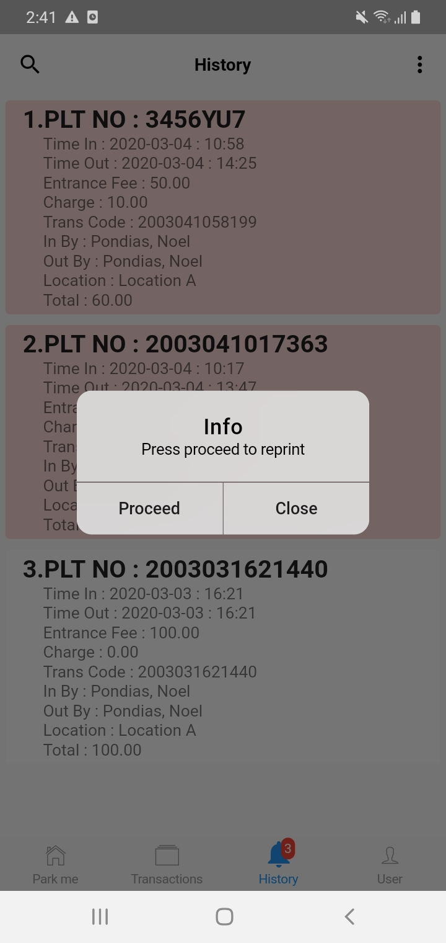

**HOW TO SYNC TO DATABASE**

GO TO HISTORY MENU

SYNC- DATA FROM THE TABLET WILL BE TRANSFERRED TO DATABASE SERVER OR ADMIN

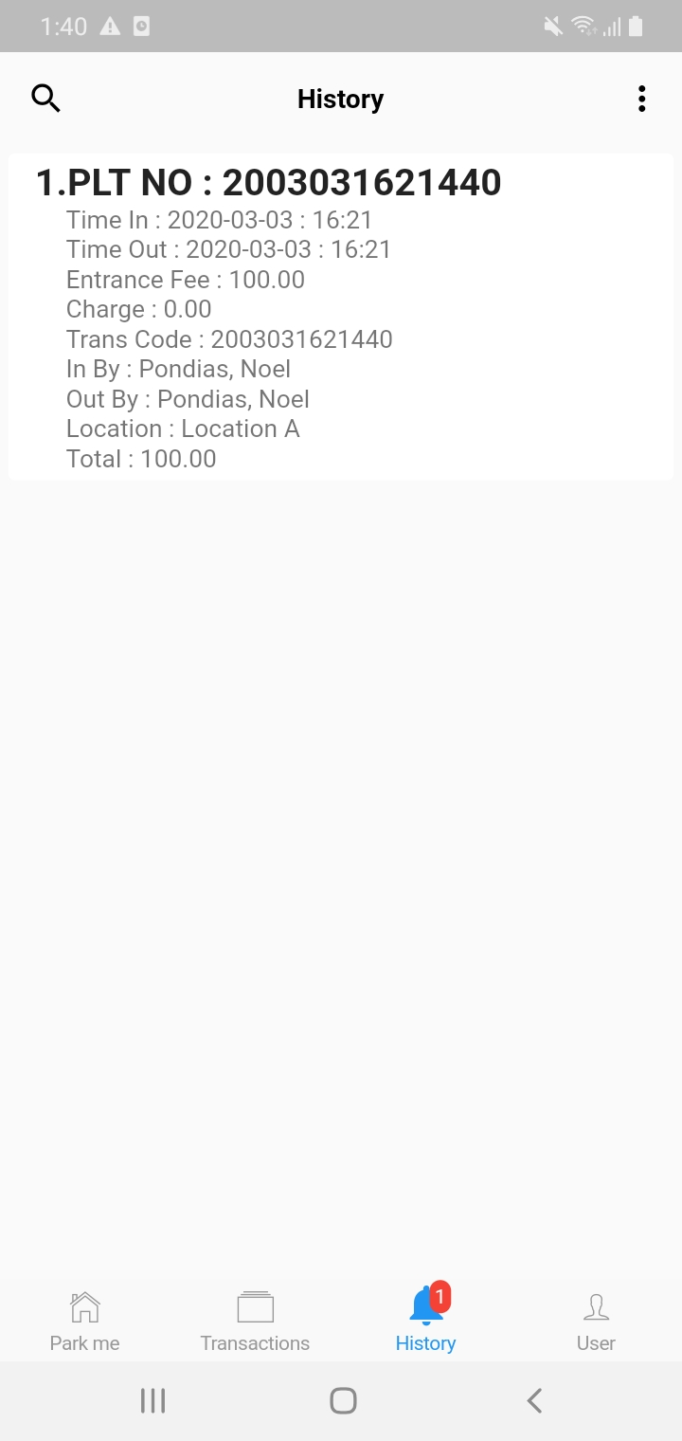

CLICK



SELECT DATABASE SYNC

